ES 104: Laboratory # 5 Summer 2022
VOLCANISM AND VOLCANIC LANDFORMS

Introduction
TASK 1 – Before you begin the lab, watch a short YouTube video on volcano types at the following URL: https://www.youtube.com/watch?v=DnBggrCdkN0
Volcanoes are classified into several major types depending on the size and shape of the landform. A shield volcano forms a gently sloping dome built of numerous highly fluid lava flows of basaltic composition. A composite volcano or stratovolcano forms a conical shaped mountain with steep sides composed of interbedded layers of viscous lava and pyroclastic material. The lavas in a composite volcano consist of andesite, dacite, and rhyolite. Pyroclastic refers to volcanic ash or any other airborne particles ejected from a volcano. Cinder cones are generally steep sided, conical shaped hills primarily composed of pyroclastic material with minor lava flows. The Cascade Range of the western United States contains all three volcanic forms.
During this lab, you will compare two very different volcanic areas – Hawaii and Mount St. Helens. You will make observations, accumulate a database, organize it into tabular form, and make direct comparisons. It is likely you will need your textbook to make some interpretations of the data, so be sure to bring it to lab.

Objectives
- Compare the morphology of two different types of volcanoes.
- Determine the tectonic setting of two specific volcanoes.
- Examine volcanic rock types in context of their volcano type.

Useful Websites
- http://hvo.wr.usgs.gov/
- http://www.soest.hawaii.edu/GG/HCV/kilauea.html
- http://www.nps.gov/havo/
- http://vulcan.wr.usgs.gov/Volcanoes/Hawaii/framework.html
- http://www.fs.fed.us/gpnf/mshnvm/
- http://vulcan.wr.usgs.gov/Volcanoes/MSH/
- http://pubs.usgs.gov/gip/msh//

Name_____________________________________
Lab day ______Lab Time_____________________

Pre-lab Questions – Complete these questions before coming to lab.

- What are the differences between cinder cone volcanoes, shield volcanoes, and stratovolcanoes? (see lab intro for information)

- What type of volcano is Mt. Hood? How do you know? What distinguishes it?

- What is the difference between a pyroclastic volcanic deposit and a lava flow?

- What is the difference between volcanic ash and lapilli?

- Define viscosity and explain how it relates to composition of lava flows?

- Do all volcanoes erupt in the same way and have the same shape? Why or why not?

Part A – Tectonic Environment
NOTE: Digital scanned versions of the Earth’s Fractured Surface map are available for download from the class web site.
https://people.wou.edu/~taylors/gs104/Earths_Fractured_Surface_Map_Slides.pptx

Volcanoes occur in a variety of tectonic settings. In this activity, you will examine the tectonic setting of the Hawaiian volcanoes and Mount St. Helens. Study the National Geographic map entitled The Earth’s Fractured Surface to compare the tectonic settings of the volcanic areas. Consider the following information and complete the comparison chart below:
- Type of crust on which the volcano occurs (oceanic or continental)
- Name of plate on which the volcano occurs
- Proximity to plate boundaries (along plate margin or intraplate)
- Relation to other volcanoes in the area (isolated, in middle of chain, at end of a chain, in center of a wide volcanic area)
- Summarize the plate tectonic setting

Table 1: Tectonics comparison chart.
Points of Comparison | Hawaiian Volcanoes | Mt. St. Helens

Type of Crust

- Plate

- Proximity to
Plate Boundaries
- Relation to
other volcanoes
- Summary

Part B – Topography
Note: Before you proceed, watch a short training video on drawing topographic profiles at the following URL: https://www.youtube.com/watch?v=StDYPIuk25M

Volcanoes are classified based on their topographic expression. This activity focuses on the topography on Mauna Loa, on the island of Hawaii, and Mount St. Helens. Figure 2 shows topographic maps of each volcano drawn at the same scale. Construct topographic profiles of both volcanoes on Figure 1. (A-A' of Mount St. Helens, and B-B' of Mauna Loa). Place the peaks of the volcanoes near the center of the horizontal axis.

Figure 1: Grid for constructing
topographic profiles.

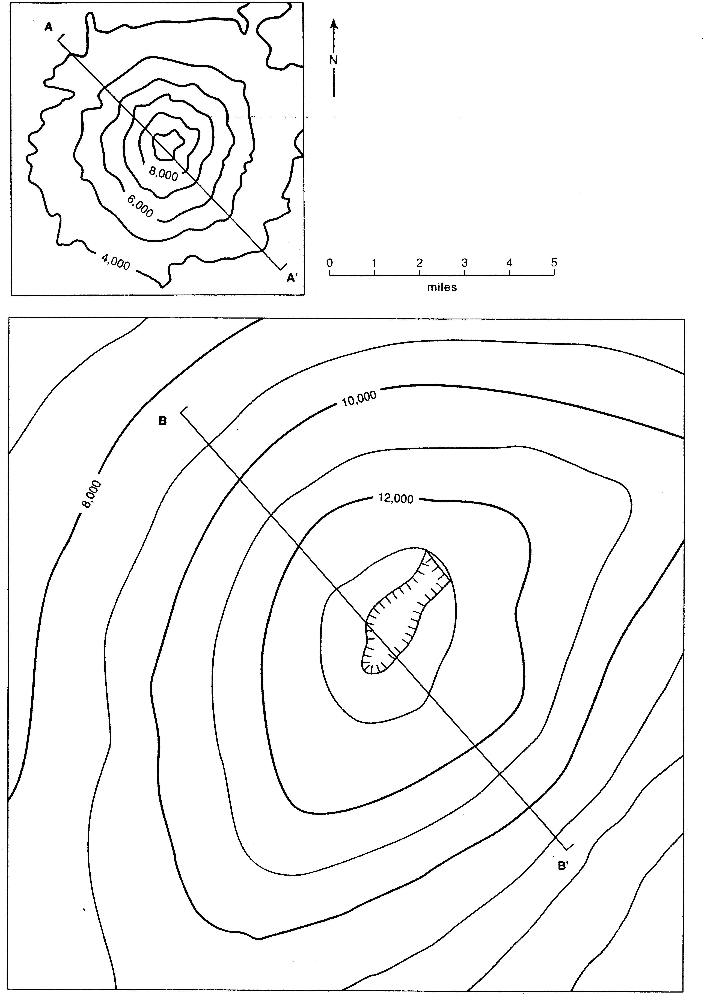
(A)

(B)

Figure 2: Topographic maps.
(A) Mount St. Helens, Washington. (B) Mauna Loa, Hawaii.
NOTE: Before you proceed, watch the training video on calculating topographic slope using a topographic map at the following URL: https://www.youtube.com/watch?v=3QFJ_uv2mGw

Study the topographic similarities and differences between shield and composite volcanoes. Consider the following information for each volcano and complete the comparison chart below.
- Describe the morphology of the volcano (shield, composite cone, or cinder cone).
- Measure the distance across the volcano shown map view (Fig. 2).
- Determine and record the maximum elevation
- Relief of volcanic peak above the surrounding topography
- Calculate the slope of the volcano (vertical change in elevation/horizontal map distance). Use profile and map information.
- Determine the area under each profile (Assume each block on the graph represents approximately 1 million ft2)

Table 2: Topography comparison chart.
 | Points of Comparison | Hawaiian Volcanoes | Mt. St. Helens
a. | Morphology of Volcano
b. | Distance across Volcano
c. | Maximum Elevation
d. | Relief of Volcano
e. | Slope
f. | Area under profile

Show calculations (or formulas) with units in chart or below...
Part C –Rock Types and Deposits

The different types of volcanoes produce different rock types and deposits. By studying the rock types and volcanic deposits, one can determine information about the volcano that produced them. Study examples of various samples from each type of volcano. Describe the samples in terms of texture and composition, provide the correct rock name, and interpret the origin of the samples.

Table 3: Sample comparison chart.
Sample | Texture | Composition | Rock Name | Origin  (volcano type)

#5
#6
#7
#9

Study the geologic maps of Kilauea and Mount St. Helens on the next page (8.8). Compare the following attributes of the volcanic deposits of Kilauea and Mount St. Helens and complete the comparison table (Table 4) on page 8.8.
- Observed composition or compositional range for each volcano.
- Type and range of deposits produced.
- Apparent lava viscosity.
- Relative volume of deposits produced.
- Surface area affected by primary volcanic deposits.
- Inferred plumbing system (single conduit, fissures, or both)

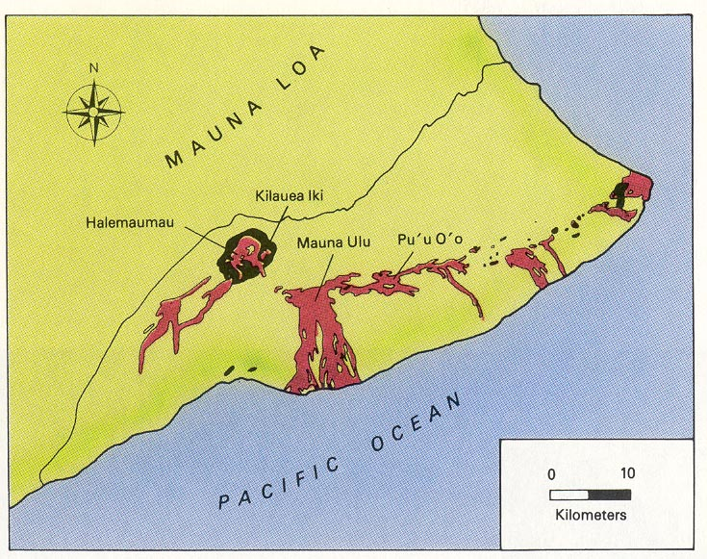 | 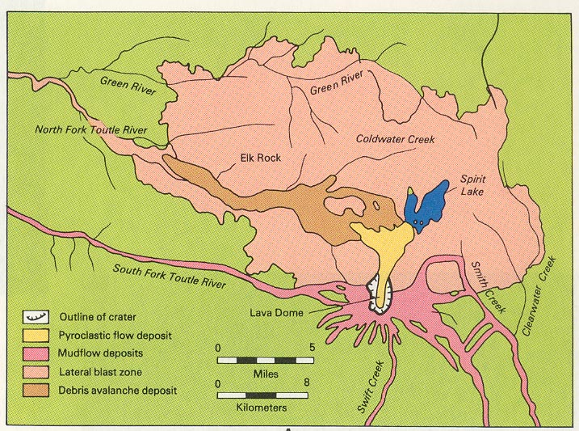
Geologic map of Kilauea:  Brown areas are lava flows formed since 1900. Black areas are pyroclastic deposits. | Geologic map of Mt. St Helens  Deposits formed from 1980 eruption.
Figure 3: Simplified geologic maps showing volcanic deposits formed around Kilauea and Mount St. Helens since 1900.

Table 4: Volcanic rock types and deposits comparison chart.
Points of Comparison | Hawaiian Volcanoes | Mt. St. Helens

Observed

Compositions
Type and Range
of Deposits
Apparent Lava
Viscosity
Relative volume of
deposits
Surface area affected

Plumbing system
(see ‘f’, pg. 8.7)

Name_____________________________________

Lab day ______Lab Time_____________________

POST LAB ASSESSMENT

  - Using differences in lava viscosity, explain why the diameter of Mauna Loa is much larger than the diameter of Mount Saint Helens.

  - Explain the relationships of lava viscosity, lava composition, and volcano morphology relative to one another.

  - Suppose 200 million years in the future, that the solidified magma chambers beneath Mauna Loa and Mount Saint Helens became exposed at the surface by erosion. What rock(s) would most likely make up the Mauna Loa magma chamber? What rocks would the Mount Saint Helens magma chamber contain?

