ES 104 Laboratory # 4 (Updated Summer 2022)

EARTHQUAKES:

Epicenter Determination, Seismic Waves, and Hazards

Introduction
Earthquakes are vibrations of the Earth caused by large releases of energy that accompany volcanic eruptions, explosions, and movements of the Earth's crust along fault lines. The earthquake vibrations are waves of energy that radiate through the Earth away from the focus. These waves of energy can be recorded on a seismograph, which produces a recording called a seismogram. Seismographs record the two types of body waves: Primary waves (P-waves) and Secondary waves (S-waves). They also detect Surface waves called Love waves (L-waves) and Rayleigh waves (R-waves).
Travel-time curves are graphs that indicate how long it takes each type of seismic wave to travel a distance measured on the Earth's surface. The difference between the S-wave arrival time and the P-wave arrival time corresponds to the distance of the seismograph station from the earthquake focus. This time difference can be converted easily into distance using the travel-time curves (Figure 2).

Goals and Objectives
- Learn to locate an earthquake epicenter using p-wave and s-wave arrival time differences and travel time curves.
- Describe the relation between earthquakes, volcanoes, and plate boundaries.
- Understand earthquake-induced liquefaction and landslide hazards and how they relate to site geology.
- Know the essential components of a seismometer and how seismometers record earthquakes.
Useful Websites
- http://quake.wr.usgs.gov/info/1906/got_seismogram_lp.html
- http://www.jclahr.com/science/earth_science/tabletop/earthshaking
- http://www.sciencecourseware.org/VirtualEarthquake/VQuakeExecute.html
- http://www.imsa.edu/programs/e2k/brazzle/E2Kcurr/Quakes/Virtual/VirtualObjectives.html
Name_____________________________________
Lab day ______Lab Time_____________________

Pre-lab Questions – Complete these questions before coming to lab.

Briefly define the following key words.

1. Earthquake

2. Primary Wave

3. Secondary Wave

4. Epicenter

5. Richter scale

6. Tsunami

Question for Thought—write a few sentences to explain:
7. How do earthquakes relate to plate tectonics?

Part A – Epicenter Determination

Before you begin, watch a short training video on YouTube from the following url: https://www.youtube.com/watch?v=ta_f321InnM
The epicenter of an earthquake is the point on the Earth's surface at or above the earthquake's focus. In this exercise, you will determine the location of the epicenter of an earthquake that was recorded on seismograms at three different locations (Figure 1).
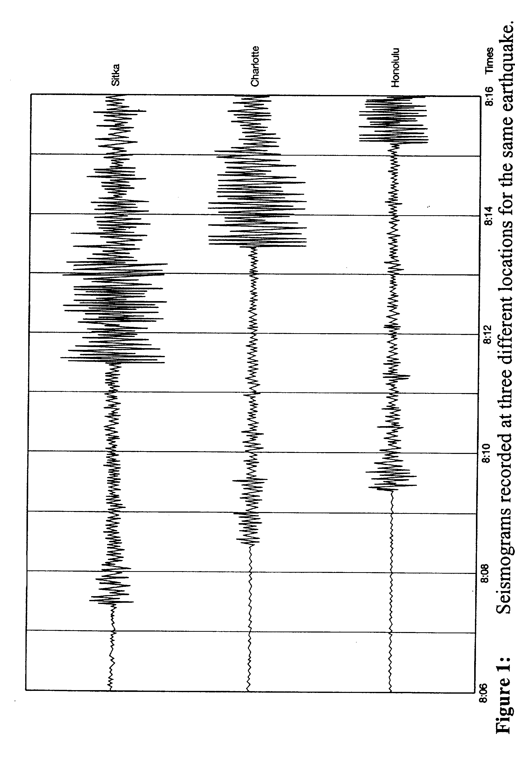

Figure 2: Travel-time graph to determine the distance to the epicenter.

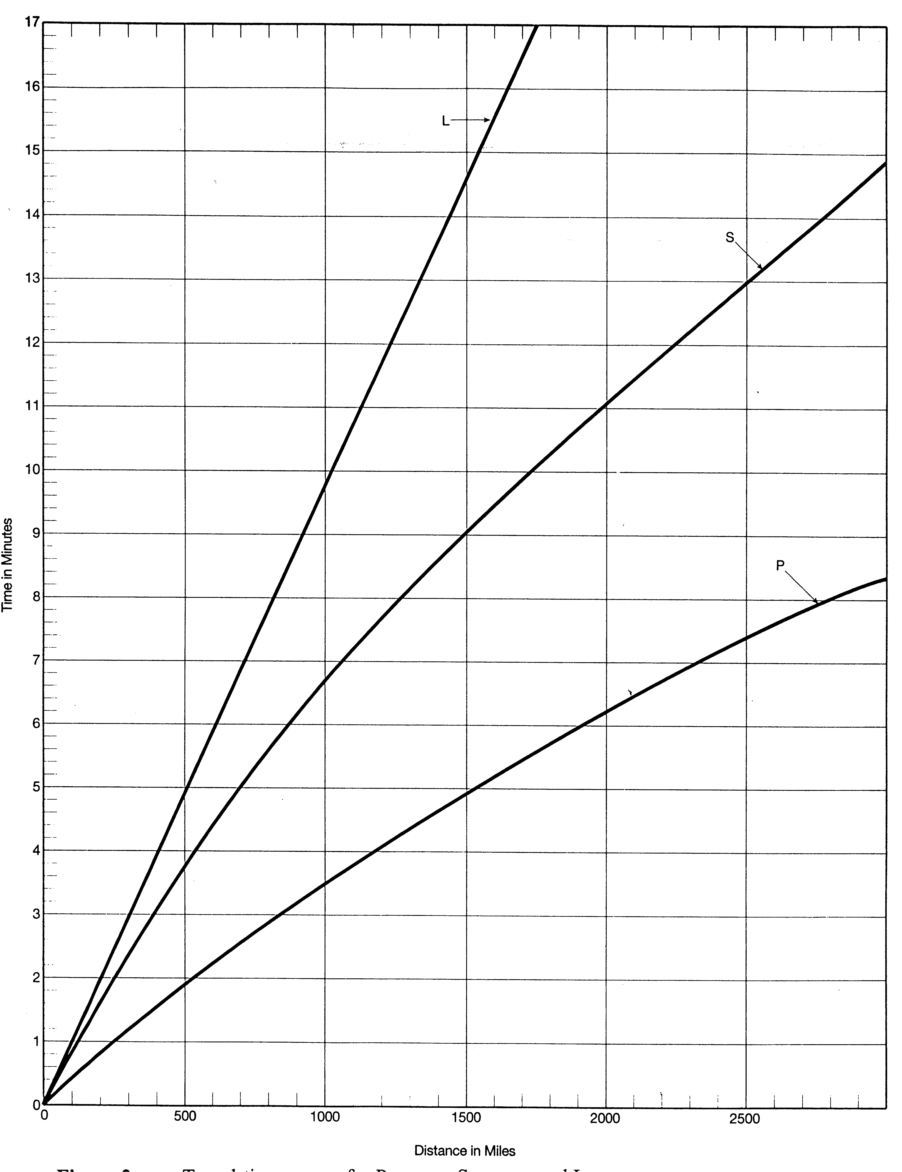

Figure 3: Travel-time curves for P-waves, S-waves, and L-waves.
- Use Figure 1 to estimate to the nearest tenth of a minute (don’t convert to seconds), the times of the first arrival of the P-waves and S-waves at each station: Sitka, Charlotte and Honolulu. Times show it arrived after 8 AM. Find the time difference, (subtract P-wave arrival time from the S-wave arrival time) to determine the difference in travel time of P-wave and S-wave.

Location of seismic station | First P-wave Arrival  (time as hour: minute.tenths) | First S-wave Arrival  (time as hour: minute.tenths) | Difference in arrival time between S & P
Sitka, AK
Charlotte, NC
Honolulu, HI

- Using Figure 2, the distance based on difference of arrival time, estimate the distance from the epicenter of the earthquake to each station. Record in the table below.

Location | Distance (miles)
Sitka, AK
Charlotte, NC
Honolulu, HI

- To find the earthquake's epicenter using the distances you just obtained, follow these steps:
- Locate and mark the three seismic stations on the world map, Figure 4 (page 5.8):

Sitka, AK: 57° N latitude, 135° W longitude
Charlotte, NC: 35° N latitude, 81° W longitude
Honolulu, HI: 21° N latitude, 158° W longitude
- On Figure 4, draw a circle around each seismic station you located with a radius of the distance the epicenter was from that station (as you determined and recorded on page 5.6). Use a drafting compass to draw each circle, and use the scale at the bottom of the map to set the radius to the proper distance. The circles you draw should intersect at one point, which is the epicenter. (If the three circles do not intersect at a unique point, estimate a point equal distance between the three circles.) The location of the epicenter is:

Latitude __________Longitude ______________

- Use the data from a single station to determine when the earthquake occurred. From Figure 1, you know when the P-waves began to arrive. From Figure 2, you know how far away it was. And from Figure 3, you can find out how long it took to arrive. So, you can determine the origin time of the earthquake.
Note the station you chose to use. _______________________
Show your calculations.

Origin time: ______________________________
(Hint: the earthquake occurs before it arrives at a station)
- What time would you estimate did the L-waves from this earthquake begin to arrive at the Sitka station? (Use Figure 3)

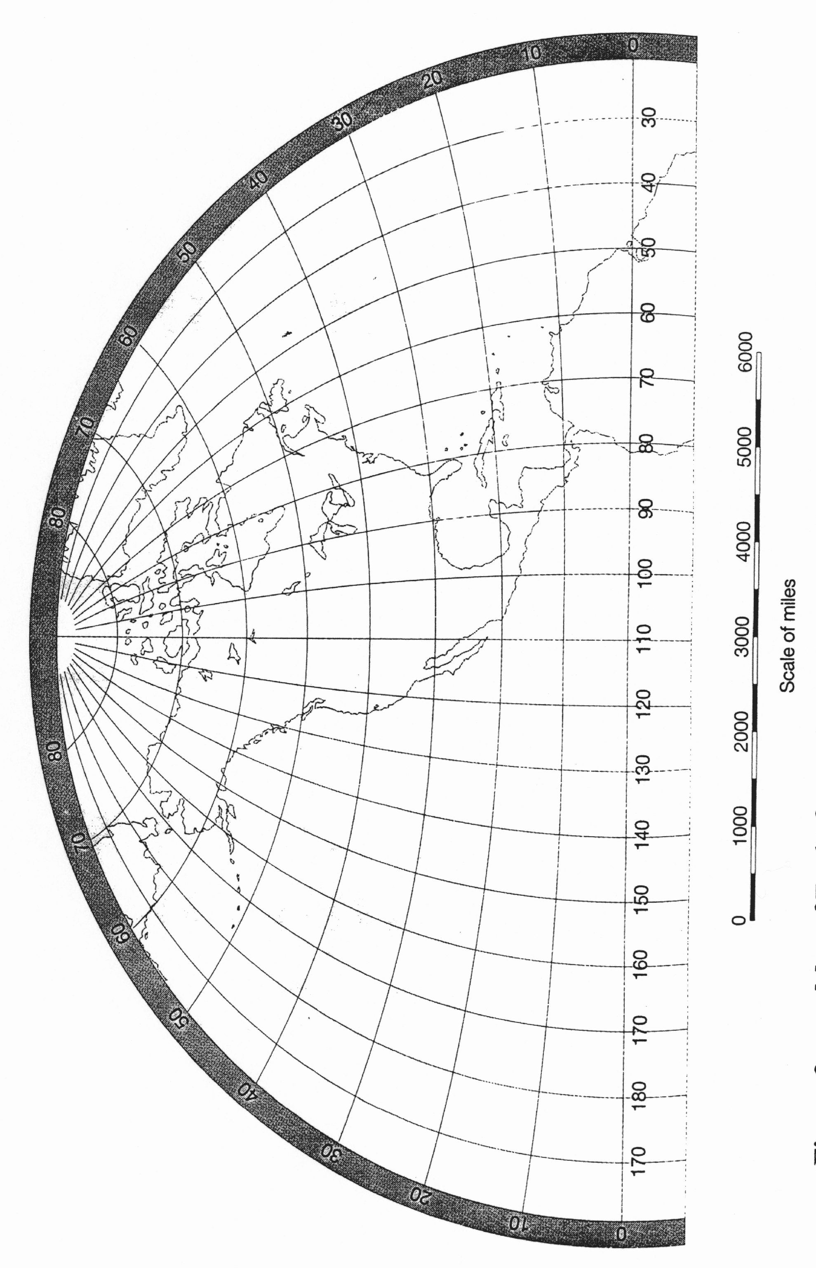

Figure 4: Map of Earth, for use in plotting data and locating the earthquake's epicenter.

Part B – Liquefaction

(Note: This Activity to Be Determined by Instructor)

During earthquakes, soils and sediments saturated with water can lose their shear strength and begin to act like a fluid. This process is called liquefaction. In this experiment, you will cause sand saturated with water to liquefy.

Directions (Your instructor may do this as a class demonstration.)

- Remove the 1 kg mass from the sand-containing column if the previous group has not already done so. If you cannot locate the 1 kg mass, it may be buried in the sand. Dig around until you find it.

- Lift the column containing only water approximately 2 feet off the tabletop. You should see water flow up through the bottom of the sand in the other column. Allow water to flow into sand-containing column until all of the sand is suspended in the water. This, by the way, is how quicksand forms!

- Place the water-containing column back on the table. Watch as the sand settles out of the water. This settling process causes the sand to be very loosely packed. Loose packing of sediment deposits increases the likelihood of liquefaction during an earthquake.

- Once the water level in the sand-containing column has dropped to the surface of the sand, gently place the 1 kg mass on the sand. The 1 kg mass represents a building constructed on loosely packed, water-saturated sediment.

- To simulate an earthquake, strike the sand-containing column sharply with the rubber mallet, aiming for the black X. Be careful not to hit the vertical plastic tubes on the outside of the column.

Questions

- What happened to the 1 kg mass when the column was struck with the rubber mallet? Given this result, what sorts of hazards does liquefaction pose to buildings during an earthquake?

- In order for liquefaction to take place during an earthquake, the soils and sediments need to be saturated with water. How do you think the depth to the water table relates to the liquefaction hazard in a particular location? (Note: the water table is the top of the zone of sediments in the subsurface that are completely saturated with water. If you drill a water-well in your backyard, you hope that your well will reach the water table.)

- Based on your observations while preparing for the liquefaction experiment, in what types of locations do you think you would find loosely-packed, liquefaction-prone sediment deposits? Can you think of any towns or cities in Oregon that might be built on these types of sediment deposits?

- Remove the 1 kg mass from the sand. Firmly tap the side of the sand-containing column several times while watching the sand closely. Place the mass back on the sand and strike the X on the side of the sand-containing column. What happened to the mass this time? Why?

- Does this result suggest any ways that liquefaction prone building sites could be prepared before construction to reduce damage due to liquefaction during a future earthquake?
Part C – Earthquakes Hazards

Examine the Geologic Map of the West Salem Area and the Earthquake Hazard Maps for this area. Answer the following questions:

- Locate Minto Island (central) and McNary Field (southeast) on the Geologic Map of the West Salem Area (which includes the western part of downtown Salem, as well as the city of West Salem). These areas are underlain by sediments labeled Qal, Qtlw, and Qlg. Write the name of the formation, and a brief description of the amounts of gravel, sand, silt and clay in each formation.
  - Qal

  - Qtlw

  - Qlg

    - Explain how the abundance/concentration of groundwater contained in these sediments may change in relation to the proximity of the Willamette River.

    - How does the type of sediment (Qal, Qtlw, or Qlg) relate to the liquefaction potential and relative earthquake hazard potential of these areas? (Refer to the Liquefaction Susceptibility Map and Relative Earthquake Hazard Map of the Salem area to support your answer.) What is the relationship between sediment grain size and liquefaction hazard?

    - How does site proximity to a river relate to liquefaction hazard? (If you completed Part C, use your liquefaction observations from Part C in your answer,).
    - Using the Geologic Map of West Salem Area, locate areas along the Willamette River that are underlain by Eocene-Oligocene sedimentary rocks (Toe). Would you build a beautiful new home overlooking the Willamette River in these areas? Why or why not? (Hint: Examine the Liquefaction Susceptibility Map, Landslide Susceptibility Map, and Relative Earthquake Hazard Map of the Salem area.)

Fill in the following table by writing in “yes” or “no” for each of the following conditions at each of the three locations found on the Geologic Map of the West Salem Area.

Location | Located on surface sediments (non-bedrock units on map) | High risk of Landslides  (see landslide susceptibility map) | High risk of Liquefaction  (see liquefaction susceptibility map) | Located in Zones A and B on the Earthquake Hazard Map.
Fairview Hospital (Fairview Home on some maps)
Marion Square Park
Salem Heights and Morningside Schools

Rank the three locations above from greatest to least susceptible to earthquake damage:

Part D - Seismometers
Seismometers are instruments designed to measure and record ground motion during an earthquake. The record kept by the seismometer is called a seismogram. Examine the seismometer at Lab Station B. The heart of the seismometer is a mass (the washers and magnets on the eye bolt in the bottle) suspended on a spring. During an earthquake, the housing of the seismometer (bottle, PVC pipe, and base) move, but the mass remains roughly stationary due to its inertia. To record the motion of the bottle relative to the mass on the spring, a coil of wire is wrapped around the bottle. The magnet on the bolt produces a changing magnetic field as it moves inside the wire coil. The changing magnetic field produces an electrical voltage in the coil. The computer measures the voltage and creates a plot of voltage vs. time; the larger the voltage, the larger the velocity of the mass.
- Given that the purpose of the seismometer is to measure motion during an earthquake, why is the mass on the spring suspended in oil? (Hint: consider how long the mass would vibrate after an earthquake if no oil were present.)

- Real seismometers are extremely sensitive to ground motion and therefore record ground motion due to sources other than earthquakes. What sorts of natural and human-caused ground motions might show up as noise on a seismogram?

- This seismometer is set up to measure vertical ground motions. Draw a picture of a seismometer that could measure horizontal ground motions. (You only need to draw the mass and whatever is attaching the mass to the seismometer housing).
Making Earthquakes
You are going to simulate earthquakes and record them on this seismometer. To simulate the earthquakes, you will drop 1 kg and 0.2 kg masses onto the wooden squares attached to the plywood base. The differing masses correspond to earthquakes of different size. Energy from the mass hitting the table will travel down the plywood base as an elastic wave where the wave will move the seismometer. The seismometer will then make a record of its motions. During a real earthquake, energy released at the focus of the earthquake travels to distant seismometers through seismic waves.
Directions
- Do not mess with any of the electronics attached to the seismometer!!!
- Delete all previous data runs on the computer (Use the menu command Experiment>Delete ALL data runs).
- Press Start to begin recording data from the seismometer.
- Carefully drop the 1 kg mass from a height of 6.5 centimeters above the wooden block labeled 1. Use a ruler to measure the height precisely.
- Carefully drop the 1 kg mass from a height of 6.5 centimeters above the wooden block labeled 2.
- Now repeat the drops at the two wooden blocks using the 0.2 kg mass. Be sure to keep the drop height at 6.5 centimeters.
- Press Stop on the computer to stop recording data.
- Adjust the horizontal and vertical scales on your seismogram so that all four earthquakes fit on the graph. Print your seismogram and label the 4 earthquakes with the mass dropped and the location of the earthquake.
Questions
- Look at the seismogram that you made. How does the amplitude of the ground motion recorded by the seismometer relate to the magnitude of the earthquake (or in this case, the size of the mass dropped)?

- How does the amplitude of the ground motion recorded by the seismometer depend on the distance to the earthquake epicenter for a given earthquake magnitude?

- Use this observation to explain why earthquake magnitude scales must correct for the distance from the seismometer to the earthquake epicenter to assign a magnitude to an earthquake using ground motion amplitudes recorded on a seismogram.

- Compare the duration of strong shaking between the 1 kg earthquake and the 0.2 kg earthquake.

- How does the duration of shaking relate to the earthquake magnitude? How do you think this affects the amount of damage that occurs to buildings during an earthquake?
Name____________________________________

Lab day ______Lab Time_____________________

POST LAB ASSESSMENT

The Global Positioning System consists of a network of satellites that send out signals that are picked up by GPS receivers, such as the models used for navigation by hikers or in cars. The GPS receivers have a database indicating the location of each satellite. The satellite sends a signal of the time of broadcast. To determine their position, the GPS receivers use the known locations of the satellites, the time signals the satellites send to the receiver, and the speed of radio waves.
  - Explain how the GPS receiver calculates its position. (see above)

  - Why does it use at least four satellite signals to determine its position.

  - In lab 4 and lab 5, you have learned a great deal about earthquakes and earthquake hazards. Using this information, explain all of the factors that should be considered in determining the earthquake hazard at a given building site.

