ES 104 Laboratory # 3 (Updated Summer 2022)

INTRODUCTION TO PLATE TECTONICS

Before starting lab, watch two short youtube videos on plate tectonics:

https://www.youtube.com/watch?v=ryrXAGY1dmE

https://www.youtube.com/watch?v=ZzvDlP6xd9o

Introduction
The Theory of Plate Tectonics has revolutionized the science of Geology in the last 40 years. The theory states that the outer surface of Earth consists of seven major lithospheric plates and numerous smaller ones, and these plates move around on a ductile layer referred to as the asthenosphere. The boundaries between the lithospheric plates, which are where they interact with one another, are characterized by distinctive topographic features and catastrophic geologic processes such as earthquakes and volcanism.

Goals and Objectives
- Introduce some of the basic ideas of Plate Tectonics
- Study the Plate Tectonic setting of the western United States and parts of the adjacent Pacific Ocean basin
- Describe the relation between earthquakes, volcanoes, and plate boundaries
- Learn to use map scales to convert map measurements to real-world distances
Useful Websites
  - http://emvc.geol.ucsb.edu/downloads.php
  - http://vulcan.wr.usgs.gov/Glossary/PlateTectonics/Maps/map_juan_de_fuca_ridge.html
  - http://www.ucmp.berkeley.edu/geology/tectonics.html
  - http://terra.chemeketa.edu/Faculty/fraa/geology/topics/tectonics/photos/htmls/world-sea-floor2.html
  - http://terra.chemeketa.edu/Faculty/fraa/geology/topics/tectonics/photos/htmls/pacific-sea-floor.html
  - http://vulcan.wr.usgs.gov/Glossary/PlateTectonics/Maps/map_plate_tectonics_world.html
Name____________________________________
Lab day ______Lab Time_____________________

Pre-lab Questions – Complete these questions before coming to lab.

Briefly define the following key words, drawing diagrams where necessary, and answer the questions.

- Lithosphere

- Asthenosphere

- Divergent Plate Boundary

- Convergent Plate Boundary

- Transform Plate Boundary

- At what type of plate boundary is western Oregon located?

- What type of plate boundary is found in southern California?

- On the back of the page, sketch a cross-section of Earth, showing the internal structure. Include inner core, outer core, lower mantle, upper mantle, asthenosphere, lithosphere, moho, oceanic crust, continental crust (you may need an inset for the relationship of the last few items).

Part A—“The Earth’s Fractured Surface” Map
NOTE: Scanned digital versions of the Earth’s Fractured Surface map are available for download from the class web page.

https://people.wou.edu/~taylors/gs104/Earths_Fractured_Surface_Map_Slides.pptx

Examine the National Geographic map “The Earth’s Fractured Surface”, and answer the following questions:

- What type of crust is present where most divergent plate margins occur?

- Name some areas that have chains of active volcanoes?

- If these are associated with plate boundaries, use the term that describes the type of plate boundary.

- Look at the Pacific Northwest area. What tectonic plates are there or nearby which may affect that area. (There are several.) Describe the type of boundaries that exist between these plates. (One type for each pair of plates that touch one another.)

- The margin of the Pacific Ocean basin is often referred to as the “Ring of Fire”. What evidence is shown on the map to justify this name?

- List some areas that have single or small groups of active volcanoes.
Examine the Hawaiian Islands and surrounding area. Notice the alignment of the Hawaiian Islands and submerged seamounts of the Hawaiian Ridge extending to Midway Island and beyond. This linear string has an abrupt bend, and continues as the Emperor Seamounts to the Aleutian Trench.

- What does the yellow circle with the arrow pointing to the northwest represent? (The red triangle in the center is the symbol for an active volcano.)

- Record the information this symbol gives about Hawaii.

- How can this information help you understand the formation of the Hawaiian Ridge?

- Midway Island is in the Hawaiian-Emperor chain. The volcanic rocks on Midway Island are dated at 27 million years old. It is the small island just north and slightly east of the ‘s’ of ‘Midway Is.’ on the map. Determine the rate in inches/year (rate = distance/time) and direction of plate motion of the Pacific Plate over the last 27 million years. Show your calculations with units.

- Compare your calculated value to the map data about plate movement at the Hawaiian hotspot.

- If your finger nails grow about 7.5 mm a month (they do), is the rate of motion of the Pacific Plate comparable to this? (Is the plate motion in the same ballpark as fingernails, or is it more comparable to how fast you can walk, or drive…). Show calculations to verify your answer.
- Suiko Seamount (referred to in your textbook) has yielded an age date of 65 million years. It is located at 44.5º N, 170.3º W (approximately beneath the second "R" in the word "EMPEROR"). Based on the available age data and the distribution of the Hawaiian Islands chain and the Emperor Seamount chain, discuss how the movement of the Pacific Plate has changed direction through time.

- Is this change in motion consistent with other seamount chains in the Pacific Ocean? Explain.

Find the locations of the eruptions listed in “Notable Volcanic Eruptions of the 20th Century” (Chart in the upper right corner of the map).
- At what type of plate boundary have the vast majority of the volcanic eruptions in the 20th century occurred?

- Consider the Iceland eruption of 1963. What two factors may have contributed to this eruption?

- Find the locations of earthquakes listed in “Notable Earthquakes of the 20th Century”. Does there seem to be a relationship between the magnitude of a given earthquake and the type of plate boundary where it occurred? What is this relationship?
Part B – "Living on the Edge" Map
NOTE: Scanned versions of the “Living on the Edge” map are available for download from the class web site.
https://people.wou.edu/~taylors/gs104/Living_on_the_Edge_Map_Slides.pptx

Examine the National Geographic map entitled "Living on the Edge" and answer the following questions:

- Study the earthquake patterns along the Cascadia Subduction Zone in N. California, Oregon, and Washington. Describe the area has had the largest number of earthquakes; area of the least?

- In comparison to other subduction zones worldwide, the Cascadia Subduction Zone has a distinct lack of earthquakes. In fact, there has never been an instrumentally recorded earthquake on the boundary between the down-going Juan de Fuca plate and the overriding North America plate. What are two possible scenarios for motion between the Juan de Fuca and North America plates that would lead to a lack of earthquakes on the Cascadia Subduction Zone?

- Read inset information on the map indicating that a large earthquake occurred in the geologic past along offshore Oregon. How do your reasons above relate to this earthquake?

- Using the Earth’s Fractured Surface map, compare the Cascadia and Aleutian subduction zones and speculate on why they have such different earthquake activity.

- Read the information on the map about the Cascade volcanoes. Would you consider the Cascades to be active volcanoes? Explain.

- Locate Long Valley Caldera in eastern California. Note that Mt. St. Helens shows a similar cluster of earthquakes. Suggest a reason why there have been such a large number of earthquakes in the Long Valley Caldera region.
Part C – Studying the San Andreas Fault, California
DO NOT COMPLETE

Study Figure 1 below, and answer the questions on the following page.
Put arrows on the map below (Figure 1) along opposite sides of the San Andreas Fault to show the relative sense of movement along
the San Andreas Fault. You may want to color the labeled units different colors to help you see their relationship to the fault movement.
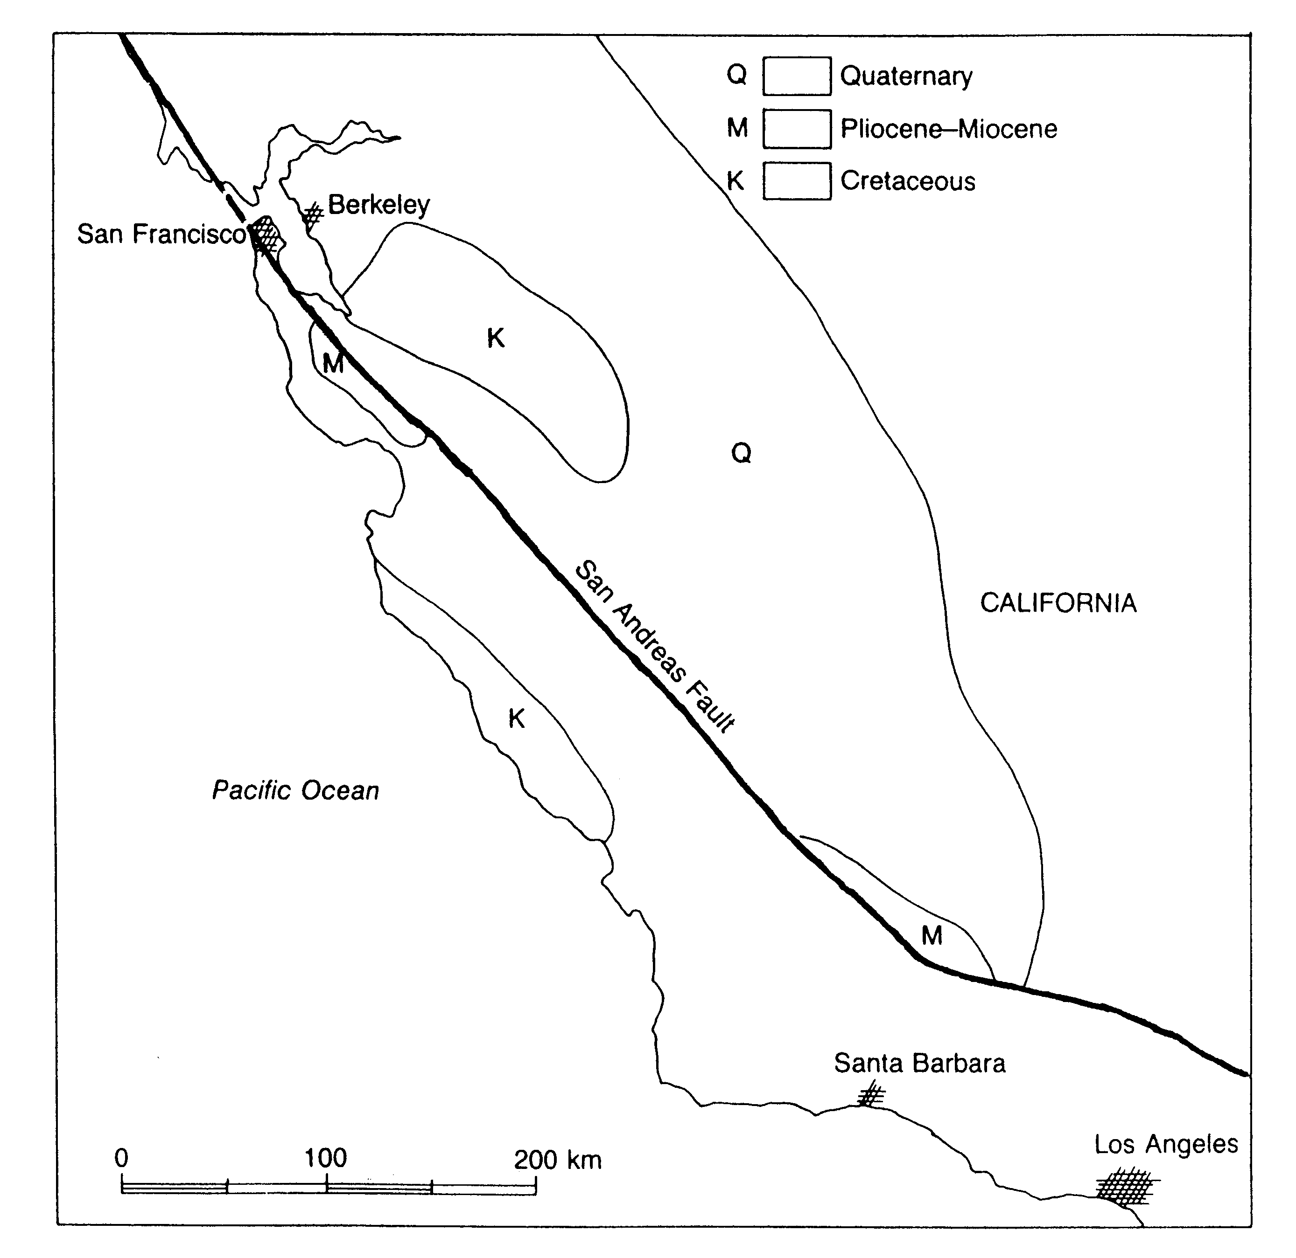

Figure 1: Generalized geologic map of central western California showing the San Andreas Fault.
- What kind of plate boundary is the San Andreas Fault?

- It is possible to estimate the average annual rate of movement along the San Andreas Fault by recognizing rocks older than the fault that have been offset by the fault. Note that Pliocene-Miocene (M) rocks, dated as being 25 million years old, have been cut and offset by the fault. You can determine how far they moved using the graphical scale at the bottom of the map, Figure 1. What is the average annual rate of fault movement in centimeters per year (cm/yr)? Show all your work, including units.

- The average yearly rate of movement on the San Andreas Fault is very small. Does this mean that the residents of southern California are safe from earthquake damage caused by earthquakes on this fault? Explain.

- The movement along the San Andreas Fault associated with the 1906 San Francisco earthquake was about 5 meters. Assuming that all of the displacement along the San Andreas Fault over the last 25 million years was produced by earthquakes with 5 meters of displacement, calculate the average recurrence interval (number of years between earthquakes) for these earthquakes. Show all your work, including units.
Name____________________________________
Lab day ______Lab Time_____________________

POST LAB ASSESSMENT
Today, we can directly measure motion of the plates using Global Position System.
- What is different about using GPS to measure the plate motion rates, instead of calculating the rate using rock ages and hotspot tracks?

- The GPS rates and hotspot track rates generally agree with each other. What does this fact tell you about plate motions over long time periods?

Suppose the Earth’s tectonic engine ground to a halt. What would be the implications for the geologic phenomena that you examined in the lab today? Be sure to justify your predictions fully.

