ES 104 Laboratory # 2 (Summer 2022)

INVESTIGATING THE SOLAR SYSTEM

Introduction
TASK 1 – before you begin this lab, watch a short 14-minute YouTube video tour of our solar system at the following URL: https://www.youtube.com/watch?v=evWeRHMwSu0

We have sent unmanned spacecraft through the solar system, landed robot space probes on Mars, Venus, and the Moon, have landed people on the Moon, and have sophisticated telescopes to obtain data. We know that each planet and satellite (moon) has unique physical characteristics that set them apart from one another. We also know our solar system exhibits some regular patterns. During this laboratory you will try to discover some of these patterns. Much of the numerical data about our solar system, such as planetary size or distance from the sun, is so large that you will need to work with scale models. By studying planetary data we can compare and contrast conditions on other planets and their satellites (moons) to those of earth.

Goals and Objectives
- Describe similarities and differences among planets of our solar system
- Create scale models and make sketches that reasonably portray observations of components of the solar system
- Create graphs to communicate and interpret data from a variety of sources
- Use internet resources which contain current information on the solar system and cosmos
Useful Websites
  - http://www.nineplanets.org
  - http://pds.jpl.nasa.gov/planets
  - http://photojournal.jpl.nasa.gov/index.html
  - http://www.noao.edu/

Page 1.1
Name____________________________________
Lab day ______Lab Time_____________________

Pre-lab Questions – Complete these questions before coming to lab.

- Define the Astronomical Unit (AU).

- If the distance from Monmouth to Washington D.C. is 2870 miles, convert this distance to units of AUs.
(Show calculations with units.)

- List the planets in order of increasing distance from the sun.

- What are the three types of materials that make up the planets?

- Which planet is the largest in the solar system?

- Which planet is covered in liquid water?

- Which planet is the hottest planet?

Page 1.2
Part A – Scale Model of The Solar System

An astronomical unit, AU, is the average distance the Earth is from the Sun. That distance is 93,000,000 miles, 8.3 light-minutes, or 150,000,000 kilometers. It is convenient to work with AUs because the real distances are in numbers that can be cumbersome to deal with. Table 1 below shows the mean distance of the planets from the Sun (orbital distance) in AUs. Alternatively, you might find the orbital distances in terms of light-minutes more illuminating (pun intended). Choose which system of units you feel more comfortable with.
Your group will construct a scale model of the solar system based on average distance to the Sun. Your model must fit in the hallway (54 meters long), the classroom, or outside (weather permitting). You must decide the scale you will use for your model. (HINT: a good scale to start with is 1 AU = 3 floor tiles)

Table 1: Solar System Data
Planet | Radius of Planet  (Kilometers) | Mean Distance from the Sun  (AU) | Radius of Planet  (millionths of AU) | Mean Distance from the Sun  (Light-Minutes)
Mercury | 2439 | 0.39 | 16 | 3.25
Venus | 6052 | 0.72 | 40 | 6.00
Earth | 6378 | 1.00 | 42 | 8.33
Mars | 3393 | 1.52 | 23 | 12.6
Jupiter | 71,492 | 5.20 | 477 | 43.3
Saturn | 60,268 | 9.54 | 402 | 79.5
Uranus | 25,559 | 19.20 | 170 | 160
Neptune | 24,766 | 30.10 | 165 | 250
Pluto * | 1137 | 39.40 | 8 | 328
Sun | 696,000 | N/A | 4,640 | N/A

Page 1.3

Questions:

- What scale did you use for your distance?

- What pattern did you notice about the spacing of the planets from the Sun?

- Draw a sketch of your model (with spacing generally to scale) below.

- What general pattern did you notice about the relative sizes of the planets?

- Which planets have the greatest number of satellites (moons)? Note that not all of the satellites in our solar system are shown. In fact new satellites are being discovered every few years.

Page 1.4

Table 2: Planet Data

 | Mercury | Venus | Earth | Mars | Jupiter | Saturn | Uranus | Neptune | Pluto*
Mass  (x10²⁴ kg) | 0.3302 | 4.869 | 5.975 | 0.6419 | 1,898.6 | 568.46 | 86.83 | 102.43 | 0.0125
Radius (km) | 2439 | 6052 | 6378 | 3393 | 71,492 | 60,268 | 25,559 | 24,766 | 1137
Mean Density (kg/m³) | 5,427 | 5,204 | 5,520 | 3,933 | 1,326 | 687 | 1,318 | 1,638 | 2,050
Orbital Distance  (10⁶ km) | 57.9 | 108.2 | 149.6 | 227.9 | 778.3 | 1427.0 | 2869.6 | 4496.6 | 5913.5
Orbital Period (days) | 87.969 | 224.7 | 365.25 | 686.98 | 4330.6 | 10,747 | 30,588 | 59,800 | 90,591
Rotational Period (hours) | 1407.6 | 5832.5 | 23.934 | 24.62 | 9.92 | 10.5 | 17.24 | 16.11 | 153.3
Ave. Surface Temperature (Kelvin) | 440 | 737 | 288 | 210 | 165 | 134 | 76 | 72 | 50
Surface Pressure | 10⁻¹⁵ bars | 92 bars | 1.014 bars | 0.008 bars | >>100 bars | >>100 bars | >>100 bars | >>100 bars | 3 micro-bars
Atmospheric  Composition | 98% He  2% H2 | 96.5% CO₂, 3.5% N₂ | 78% N₂, 21% O₂, 1% H₂O | 95.32% CO₂, 2.7% N₂ | 90% H₂, 10% He | 96% H₂, 3% He | 83% H₂, 15% He  2% CH₄ | 80% H₂, 19% He  1% CH₄ | methane & N2

Table 3: Density of Common Materials.

Material | Density
Air | 1.2 kg/m³
Water or Water-Ice | 1000 kg/m³
Typical Rocks | 3000 kg/m³
Metal at High Pressure | 10,000 kg/m³

Page 1.5

Part B – Classifying the Planets

Study the solar system information in Table 2. The table provides information scientists believe to be true about the planets in the solar system based on the latest technology to help them. By looking carefully at the data in this table you should be able to find some patterns, similarities, and differences among the planets in our solar system. The following questions will assist you in thinking about what is considered a pattern, similarity, and difference. Questions:
- Which planet would float in water? _______________________
(Hint: Less dense objects float in denser fluids.)

- How long is a day on Jupiter? __________, (answer in Earth hours)

on Venus? ________________, on Mars? ________________

- How many Earth years go by before one Mars year has passed? ___
Show work here.

- Which two planets account for 90% of the total mass of all of the planets?
_______________________ and __________________________

- Which planet seems unusually hot, considering its distance from Sun?

__________________________________
By looking at the data in table 2, suggest a reason for this extreme high temperature.

You should also look over Table 3 which contains density information and investigate densities of the air, water, rock, and lead ore samples (lead ore approximates the density metal at high pressure). Because all of the samples have the same volume, you can investigate the effect of density directly by picking each one up and comparing their masses.

Page 1.6

- Compare the density of materials to the density of water. (Density = Mass/Volume and the samples chosen all have similar volumes). Pick up each sample and guess how its density compares to water. For each sample, note in the spaces below how many times larger or smaller you think the density is compared to water.
  - Air seems to be ____________________ times less dense than water.
  - Rock seems to be ____________________ times more dense than water.
  - Metal at high pressure seems to be ____________________ times more dense than water.

- How do your guesses compare to Table 3?

- What estimates can you make about the bulk composition of each planet based upon its density? Table 3 provides information about the density of common materials found on Earth. Compare the density of metal, rock, water ice, and gas (in table 3) to the mean density of each planet from table 2.
(HINT: You can answer in terms of mostly metal, rock, ice, or gas; or combinations of these.) Rely on tables 2 and 3; not other information.
Planet | Deduced Composition
Mercury | .
Venus | .
Earth | .
Mars | .
Jupiter | .
Saturn | .
Uranus | .
Neptune | .
Table 4:

Page 1.7

On page 1.9, make four tables: each table should contain all of the planets, and be based on a different property of the planets. Use properties of the planets (in Table 2) to group them into general categories. Write the property used for the classification in each table, and column headings for how you divided the planets using that property. For example, using the property of density, you could place the planets into two groups, high density planets and low density planets. Or perhaps the density data suggests that low, medium and high density groupings are more appropriate. Let the data be your guide to the number and types of groups that a particular property requires. (The tables are not lists in an order, but divisions into groups of similar characteristics, based on the properties of the planets.)
Write any general statements you can draw from your study of properties that could be cited as patterns in the solar system.

Part C – Graphing Planetary Data
Sometimes graphs can give you a different perspective about data that reading a table cannot. In this activity you will graph selected data from Table 2 (page 1.5). Graph paper is provided at the end of this lab (on pages 1.11 and 1.12), or you can use a spreadsheet to make a chart.
Activity: Graph the data sets below from Table 2
- _____________Mean Density vs. Orbital Distance from Sun
- _____________Surface Temp. vs. Orbital Distance from Sun
- _____________Orbital Period vs. Orbital Distance from Sun
- _____________Rotational Period vs. Orbital Distance from Sun
- _____________Mass vs. Orbital Distance from the Sun

Consider the following questions:

What does each graph tell you?

Is there a relationship between the two quantities being graphed?

If a relationship exists, provide an explanation for the relationship.

Page 1.8

Write the name of the property used to categorize the planets. Subdivide each area to categorize the planets based on properties
Table A: _______________ | Table B: _______________
Table C: _______________ | Table D: _______________
General Statements about categories:

Page 1.9

Name____________________________________
Lab day ______Lab Time_____________________
POST LAB ASSESSMENT

1. Consider the uniqueness of Earth compared to the other planets in our solar system. Make a table that identifies the characteristics Earth shares with other planets and characteristics that are unique to Earth.

Earth Characteristic | Planets that share this characteristic with Earth | Planets that are different in this characteristic
Mass
Density
Atmospheric composition
Another characteristic (write your choice)

- In the past two labs, you have explored information in a number of ways: physical models, pictorial models (sketches/diagrams), data tables and graphs. Which did you find most useful in your investigations, and why do you think it was useful for you?

Page 1.10

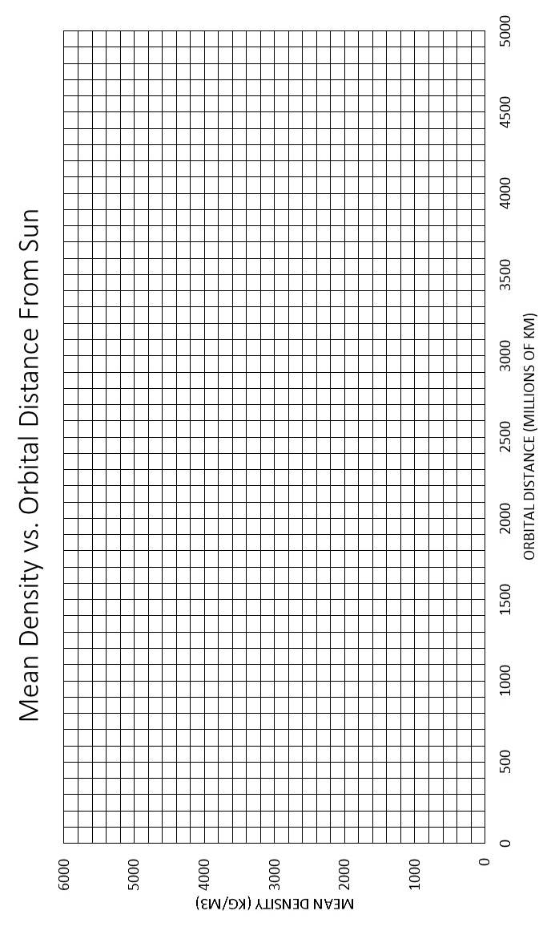 Page 1.11
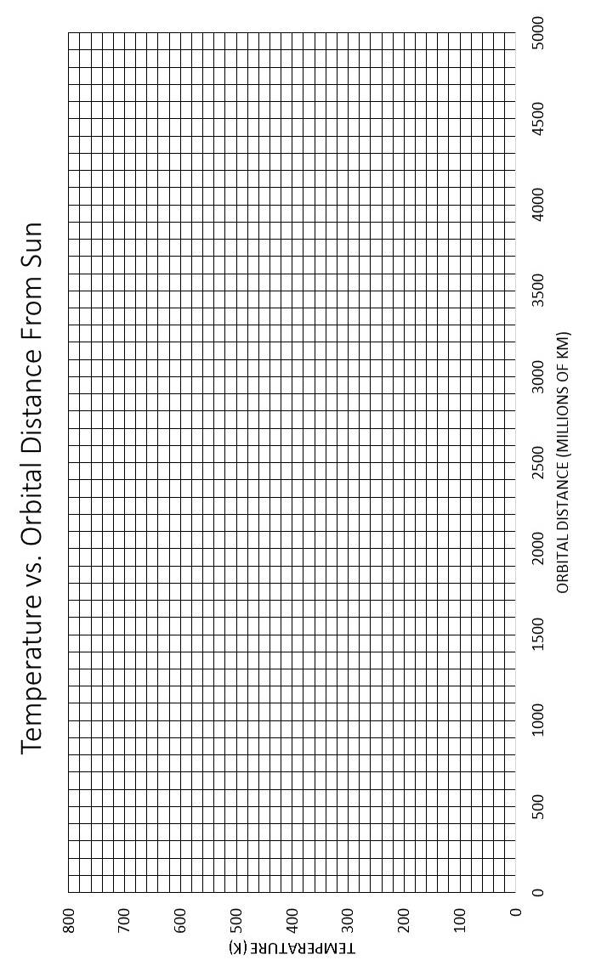
Page 1.12
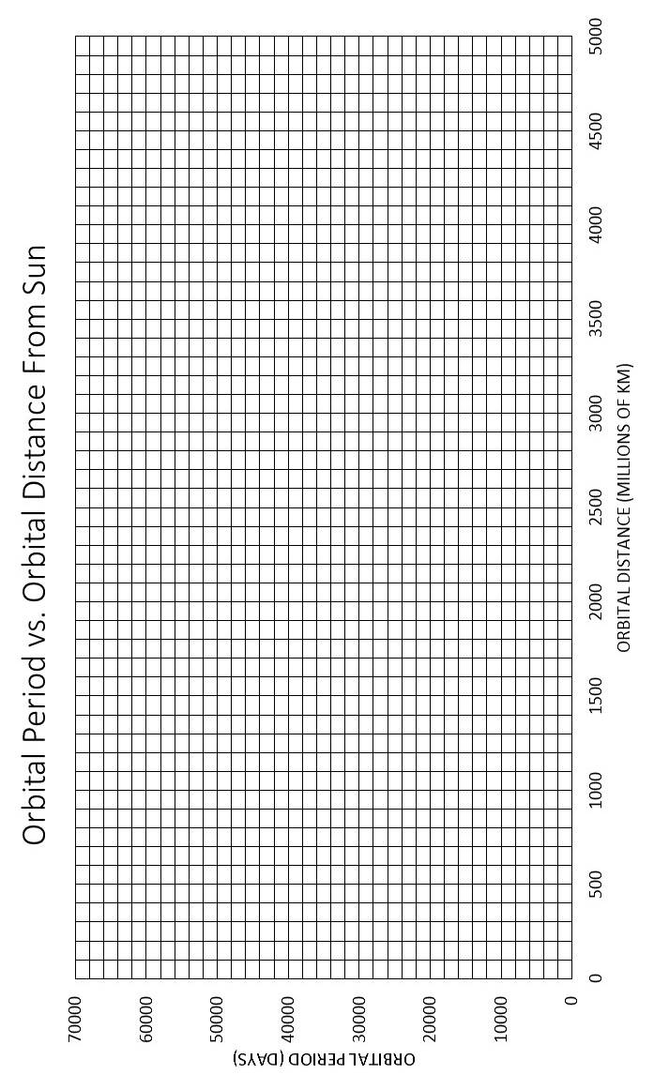
Page 1.13
Page 1.14

