ES302 Quantitative Methods Extra Effort Practice Problems Name______________
Spring 2020

Show all of your math work and unit algebra, include sketches where required.

- An area is being irrigated by a stream with a drainage area of 300 km². The drainage area contribution to the stream is 0.1 m³/sec/km². SHOW ALL MATH WORK.
  - Draw a sketch.

  - Calculate the discharge of the channel in cubic meters per second (cms).

  - Calculate the area of the watershed in hectares (ha).

  - Calculate the area of watershed that is able to be irrigated, if the irrigation requirement is 0.37 m³/sec per 1000 ha.

- The average monthly precipitation in a watershed of 4500 km² is 46 cm (average uniform precipitation depth across the watershed). If the cumulative losses to evapotranspiration and infiltration are 20% of the total rainfall input, calculate the total area in hectares that can be irrigated, if the irrigation requirement is 0.37 m³/sec per 1000 ha. SHOW ALL MATH WORK.

- Water is to be supplied to an area for both domestic and agricultural purposes. The population is 200,000 people, and the area to be irrigated is 3600 ha. Water is to be pumped from the river for supply. SHOW ALL MATH WORK.

  - If the average daily consumption is 320 liters per person and the agricultural demand is 0.33 m³/sec per 1000 ha, calculate the number of pumps that will be required in the individual pump capacity is 0.1 m³/sec.

  - The engineering plan calls for an additional 30% of total pumps, beyond the minimum required, as back up on standby in case of emergency. What is the total number of active pumps and back-up pumps needed for the job?

  - Calculate the minimum discharge of the river needed to meet total demand, in cubic meters per second.

Problems 4 through 8 are related to physical properties of Earth Materials. An equation list for density, specific gravity, and unit weight are provided below.

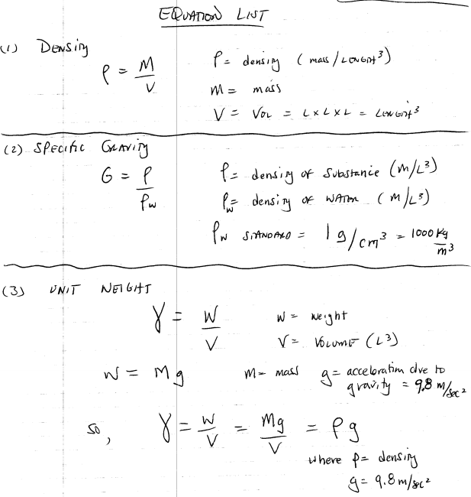

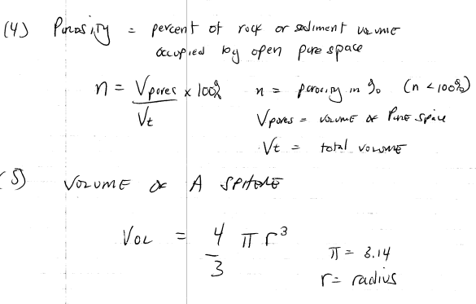

- A cylindrical sample of rock has a diameter of 6.57 cm and a length of 15.8 cm. The rock has a unit weight of 36.2 kN/m³. Draw and label a sketch. Calculate the mass of the rock sample. SHOW ALL MATH WORK.

- Calculate the volume of a rock slab with unit weight 29.5 kN/m³ and mass of 4570 kg. SHOW ALL MATH WORK.

- A block of rock has edge lengths of 1.24 m, 0.82 m, and 0.933 m. It weighs 24.7 kN. Draw and label a sketch. Calculate the unit weight. SHOW ALL MATH WORK.

- A 12.74 m³ block of rock has a porosity of 26.4%. What is the volume of this rock after the block is crushed sufficiently to close all pore spaces? SHOW ALL MATH WORK.

- A block of rock has edge lengths of 1.22 m, 2.4 m and 1.81 m. When dry, its mass is 14.7 Mg; when saturated with water its mass is 16.6 Mg. Draw and label a sketch. Calculate the porosity of the rock (note: the SI prefix M stands for “Mega” = 1 x 10⁶) SHOW ALL MATH WORK.

- An unconfined aquifer in the Willamette Valley has a water table hydraulic gradient of 0.09. The aquifer lies west of the river, and the water table slopes towards, and merges with the top of the river stage in the channel. SHOW ALL MATH WORK.

  - Draw and label a cross section sketch showing the relationships, with west oriented to the left of the drawing on the page, and east to the right.

  - Calculate the hydraulic gradient in ft / mi.

  - Calculate the hydraulic gradient in percent.

  - Calculate the hydraulic gradient in degrees.

- You are standing on a hillslope with an average uniform angle of 20 degrees. You are at point A with an elevation of 280 feet above sea level. Your goal is to hike 1.2 miles distance to the east, directly upslope to point B. Draw and label a sketch to show the relations. Calculate the elevation of Point B and your total net relief or elevation gain in feet. SHOW ALL MATH WORK.

