**ES202 Introduction to Sedimentary Rocks Online Lab Exercise Name______KEY__________**

Note: this worksheet will be uploaded to the ES486 Moodle Course Shell Assignment Page

**Part 1. Lab Manual Exercises**

Open the Sedimentary Rocks Lab Manual Exercise as posted on the class web site, located at the following URL:

<https://people.wou.edu/~taylors/es486_petro/lab_exercises_sed_rks.pdf>

**Section A. Reading review questions.** Read pages 153-160. Define the following key terms and answer review questions as presented in the reading.

1. Briefly describe the difference between “sediments” and “sedimentary rocks”

Sediments are loose aggregates of rock while sedimentary rocks are the compacted/ lithified form of sediments.

1. Briefly describe the difference between “chemical weathering” and “Physical weathering”, and related, the difference between “chemical sediment” and “detrital sediment”.

Chemical weathering refers to the breakdown of materials by means of chemical reactions like interaction with acidic liquids. It can also refer to the natural breakdown of the a mineral into its constituent elements. Physical weathering refers more to actions like abrasive action by wind or flowing water breaking the material into smaller parts.

1. Examine Figure 6.1. Summarize the processes of weathering, sediment transport, deposition, and lithification at or near the Earth’s surface.

A source rock is mechanically/chemically weathered into fragments/sediments. The sediment is then transported via wind, water, or gravity until it reaches a location of lower environmental energy like a basin, delta, lakebed, or ocean floor. At this location it would stop being transported and would settle and form a deposit. Over time it would be compacted (heat and pressure) by new sediments forming on top of it and would be lithified into a sedimentary rock.

1. Describe and define the process of lithification, what is it and how does it occur?

Lithification is the process of taking sediment and squeezing it together with great pressure until it becomes a rock. It can also occur by gluing or cementing sediments or rock fragments together with crystal growth between particles or chemical residues.

1. Examine Figure 6.2 on op. 158. Based on composition and origin of sediment, list the three primary types of sedimentary rocks. What is the difference between the three classes of rocks?

Detrital sediment is made up of pieces of other rocks. Biochemical sediment is composed of biologically based fragments like shells, corals, or plant based materials. Chemical sediments can form through processes like evaporation where a mineral is left behind as a fluid evaporates away.

1. For detrital sediment, define / describe the differences from clay, silt, sand, and gravel. What is the primary factor that separates each class of sediment?

The primary difference between detrital sediments is the size of grains and their level of sorting. Clay particles are so small that you cannot see individual grains with your eyes. Sand and gravel on the other hand, are so large that you can identify the parent materials sometimes.

1. What is the difference between the process of sediment “rounding” and sediment “sorting”, provide examples of how each is affected by sediment transport process.

Roundness involves knocking the edges and corners off of a sediment grain while sorting refers to the process of separating different sized grains from others. Both can take place during transport. As a particle is transported it can be bounced around knocking off edges and rounding it. As the environmental energy changes, the particle can be deposited with like sized grains while other smaller grains are still carried away.

1. Examine Figure 6.5 on p. 161, provide an example of the process of lithification and cementation of sand to form sandstone.

Sand is deposited and then compacted and cemented together by new mineral formations that bind the grains together.

1. Examine Figure 6.6 on p. 161, describe the process of the formation of limestone.

Shells are broken into fragments by the environment and are then compacted. Calcite crystals then grow in between the compacted shell fragments and cement them together.

1. Examine Figure 6.8 on p. 162, describe the process of the formation of chemical sedimentary rock “rock salt”

Rocks and sediments are slowly dissolved by acidic water/rain, which results in water that contains dissolved ions. As that fluid evaporates, the ions precipitate out and form deposits of chemical sed rocks.

1. Examine the Sedimentary Rock Classification Chart Figure 6.9 on p. 164. List the three procedural steps for identifying sedimentary rocks.

Step 1 is to identify the material the rock is composed of. Step 2 is to identify the texture and other identifying properties. Step 3 is to use the gathered info to assign a name.

1. Continue examining the Sedimentary Rock Classification Chart Figure 6.9 on p. 164. Describe the primary differences in composition and texture that distinguish the following sedimentary rocks (what is the basis of identification and naming for each, and list whether they are detrital, biochemical, or chemical in origin):

Conglomerate vs. Breccia : Both are detrital and they are separated by the level of angular vs rounded grains.

Quartz Sandstone vs. Arkose Sandstone: Both are detrital. Quarts sandstone has a high level of quarts sand and arkose is mostly feldspar sand.

Siltstone vs. Shale : Both are detrital. Shale is mostly clay and siltstone is mostly silt.

Fossiliferous Limestone vs. Micrite

*(Bonus Question - True or False: limestone fizzes with hydrochloric acid)*

Both are Biochemical. Limestone would contain fossils while Micrite has no visable grains. Both will react to HCL.

Rock Salt vs. Rock Gypsum

Chert

Chemical in origin, the differences are in the material each is made of. Halite crystals for the rock salt, Gypsum crystals for the gypsum, and microcrystalline quartz for the chert.

1. Examine the sedimentary environments block diagram Figure 6.10 on p. 165. List the types of environments where the following sediments and resulting sedimentary rocks may form near the Earth’s surface. In your answer, identify whether they occur in non-marine or marine settings, or both.

Chert

Siliceous ooze in deep marine setting.

Limestone

Costal and marine environments

Rock Salt

Dry lake beds and coastal regions

Rock Gypsum

Dry lake beds and coastal regions

Sandstone with marine shell fossils

Costal and marine environments

Sandstone with terrestrial plant fossils

Rivers and deltas

Conglomerate

Non- marine environments like mountains and river valleys

Breccia

Non- marine environments like mountains and river valleys

Coal

Peat bogs

Mudstone or Shale

Costal and marine environments

**Section B. Lab Manual Exercises.**  Complete the following lab manual exercises.

1. Activity 6.1 on p. 171. Examine the images of the sedimentary rocks samples, and compare to the identification chart presented on Figure 6.9 on p. 164. Answer the following questions for each sample image pictured (samples 1 through 6). The images are not the same as hand samples, and you have to do some visual guessing, do the best you can, the goal is to think about the rock type, not necessarily come up with the correct answer.

Sample 1.

Sediment composition: Detrital

Grain size: gravel

Sorting: poorly sorted

Grain Rounding: sub-rounded

Rock Name: Conglomerate

Sample 2.

Sediment composition: biochemical

Grain size: sand to gravel

Sorting: poorly sorted

Grain Rounding: sub-rounded

Rock Name: Coquina

Sample 3.

Sediment composition: chemical

Grain size: No visible grains

Sorting: well sorted

Grain Rounding: NA

Rock Name: Rock salt

Sample 4.

Sediment composition: Detrital

Grain size: sand

Sorting: well sorted

Grain Rounding: well rounded

Rock Name: Sandstone

Sample 5.

Sediment composition: Detrital

Grain size: clay, silt

Sorting: well sorted

Grain Rounding: well rounded

Rock Name: Shale with fossils

Sample 6.

Sediment composition: Detrital

Grain size: sand

Sorting: well sorted

Grain Rounding: well rounded, sub-rounded

Rock Name: Sandstone

**Section C. Online Virtual Sedimentary Rock Identification Exercise.**

Open the interactive online Sedimentary Rock Identification lab exercise as posted at the following URL:

<http://profharwood.x10host.com/GEOL101/Labs/Sediment/index.htm> This is an interactive online sedimentary rock identification lab hosted by Professor Richard Harwood; external to the WOU campus server system. The above link will take you to the Sedimentary Rock Lab Home Page shown in the screen capture below.

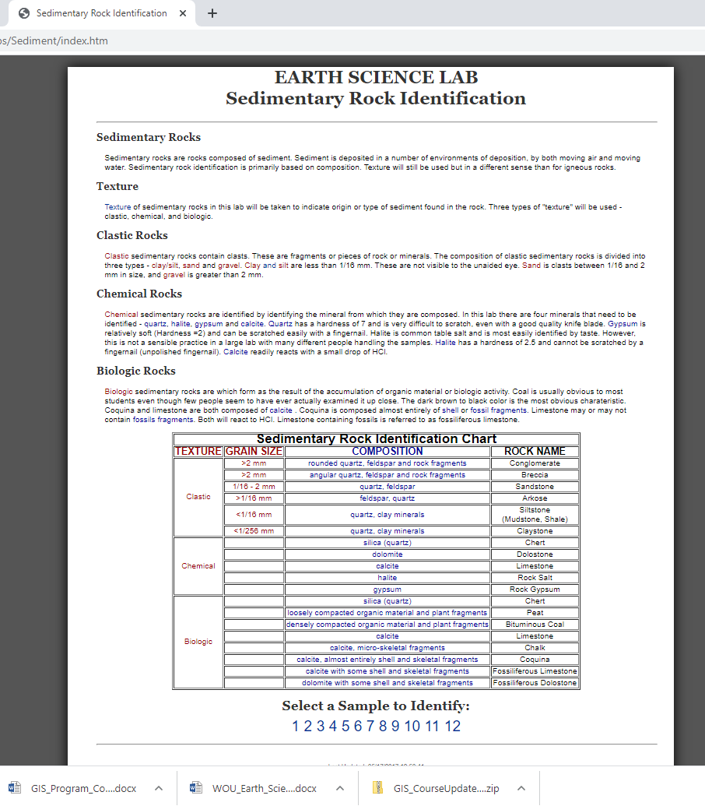

Read over the explanatory paragraphs summarizing the basics of sedimentary rock identification and classification that you learned about in Section A of the lab exercise above. Explore the linked web page showing a summary of the Sedimentary Rock Texture Chart at the following URL:

<http://profharwood.x10host.com/GEOL101/Labs/Sediment/texture.htm> and shown in the screen capture below.

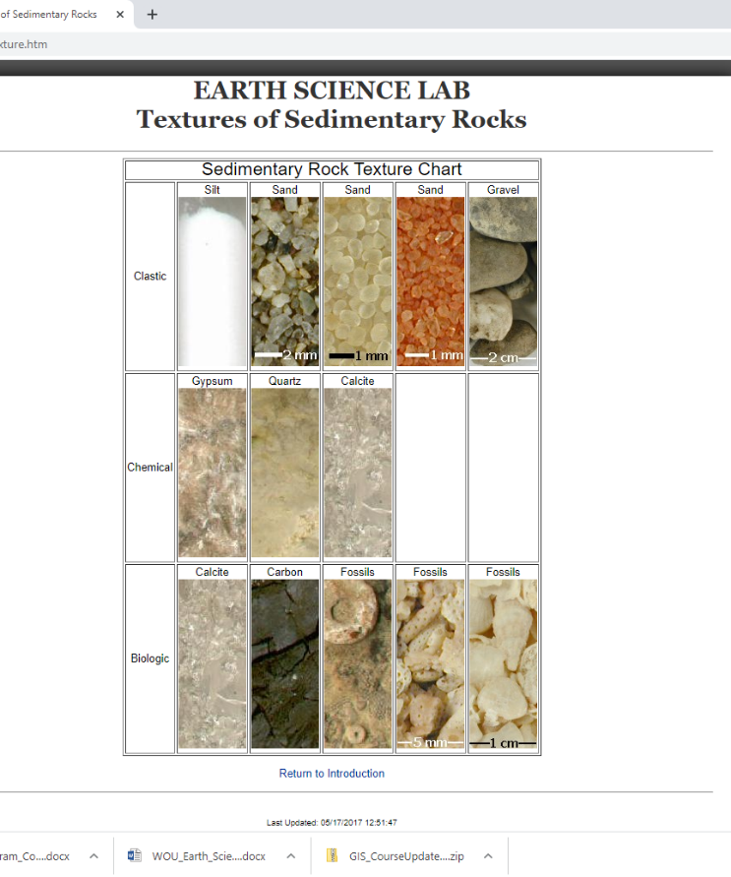

1. **Sample Identification:** There are 12 unknown sedimentary rock samples listed with links at the bottom of the lab introduction page:

<http://profharwood.x10host.com/GEOL101/Labs/Sediment/index.htm>

Note the instructions at the bottom of the page “select a sample to identify”. Systematically click through each sample from 1 to 12, and make observations regarding the sediment composition, hardness of the sediment particles, hydrochloric acid fizz test. Using the sample image, zoom in and out to make visual observations on sediment composition and grain size. Use the interactive radio buttons to test for acid effervescence (“fizz”) and hardness (on scale of 1-10), and finally compare your observations to the rock classification chart shown on the Sedimentary Rock Classification Chart Figure 6.9 on p. 164, from Section A you completed above.

Once you have made your observations, fill out the interactive rock classification chart using the radio buttons in each section of the web page: Texture, Grainsize, Composition, Rock Name. Once you have made your observations and decisions on how to classify the rock sample image, click on the “Grade Identification” control button, for feedback on how you did on your observations. If you have correctly made observations and identified the sedimentary rock sample, you will receive a pop-up note that you are “correct” and will win the grand prize. If you have incorrectly made observations or mis-named the unknown sample, you will receive a pop-up message stating that “You Missed the Texture, Grain Size, Composition, Rock Name”; retry as many times as needed to come up with the correct answers for the unknown samples. **Once you have completed to exercise to your liking, with correct answers through observation, trial and error, fill in the data tables below for each specimen, summarizing your online results on this worksheet.**

**Sample 1**

Acid Fizz Test = yes

Hardness Observations: 3

Texture: Chemical

Grainsize: no grain size

Composition: calcite

Rock Name: Limestone

**Sample 2**

Acid Fizz Test = yes

Hardness Observations: 3

Texture: Biologic

Grainsize: no grain size

Composition: calcite, almost entirely shells and skeletal fragments

Rock Name: Coquina

**Sample 3**

Acid Fizz Test = no

Hardness Observations: 2

Texture: Chemical

Grainsize: no grain size

Composition: Gypsum

Rock Name: Rock Gypsum

**Sample 4**

Acid Fizz Test = yes

Hardness Observations: 3

Texture: Biologic

Grainsize: no grain size

Composition: calcite with some shell and skeletal fragments

Rock Name: Fossiliferous Limestone

**Sample 5**

Acid Fizz Test = no

Hardness Observations: 5

Texture: Clastic

Grainsize: <1/16 mm

Composition: quartz, clay minerals

Rock Name: Siltstone (Mudstone, Shale)

**Sample 6**

Acid Fizz Test = no

Hardness Observations: 5

Texture: Clastic

Grainsize: >1/16 mm

Composition: feldspar, quartz

Rock Name: Arkose

**Sample 7**

Acid Fizz Test = no

Hardness Observations: 2

Texture: Chemical

Grainsize: no grain size

Composition: Gypsum

Rock Name: Rock Gypsum

**Sample 8**

Acid Fizz Test = no

Hardness Observations: 5

Texture: Clastic

Grainsize: >2 mm

Composition: rounded quartz, feldspar and rock fragments

Rock Name: Conglomerate

**Sample 9**

Acid Fizz Test = no

Hardness Observations: 7

Texture: Chemical

Grainsize: no grain size

Composition: silica (quartz)

Rock Name: Chert

**Sample 10**

Acid Fizz Test = no

Hardness Observations: NA

Texture: Clastic

Grainsize: 1/16 - 2 mm

Composition: quartz, feldspar

Rock Name: Sandstone

**Sample 11**

Acid Fizz Test = no

Hardness Observations: NA

Texture: Clastic

Grainsize: 1/16 - 2 mm

Composition: quartz, feldspar

Rock Name: Sandstone

**Sample 12**

Acid Fizz Test = no

Hardness Observations: NA

Texture: Biologic

Grainsize: NA

Composition: densely compacted organic material and plant fragments

Rock Name: Bituminous Coal