**ES486 Introduction to Sedimentary Rocks Online Lab Exercise Name___________________**

Note: this worksheet will be uploaded to the ES486 Moodle Course Shell Assignment Page

**Part 1. Lab Manual Exercises**

Open the Sedimentary Rocks Lab Manual Exercise as posted on the class web site, located at the following URL:

<https://people.wou.edu/~taylors/es486_petro/lab_exercises_sed_rks.pdf>

**Section A. Reading review questions.** Read pages 153-160. Define the following key terms and answer review questions as presented in the reading.

1. Briefly describe the difference between “sediments” and “sedimentary rocks”
2. Briefly describe the difference between “chemical weathering” and “Physical weathering”, and related, the difference between “chemical sediment” and “detrital sediment”.
3. Examine Figure 6.1. Summarize the processes of weathering, sediment transport, deposition, and lithification at or near the Earth’s surface.
4. Describe and define the process of lithification, what is it and how does it occur?
5. Examine Figure 6.2 on op. 158. Based on composition and origin of sediment, list the three primary types of sedimentary rocks. What is the difference between the three classes of rocks?
6. For detrital sediment, define / describe the differences from clay, silt, sand, and gravel. What is the primary factor that separates each class of sediment?
7. What is the difference between the process of sediment “rounding” and sediment “sorting”, provide examples of how each is affected by sediment transport process.
8. Examine Figure 6.5 on p. 161, provide an example of the process of lithification and cementation of sand to form sandstone.
9. Examine Figure 6.6 on p. 161, describe the process of the formation of limestone.
10. Examine Figure 6.8 on p. 162, describe the process of the formation of chemical sedimentary rock “rock salt”
11. Examine the Sedimentary Rock Classification Chart Figure 6.9 on p. 164. List the three procedural steps for identifying sedimentary rocks.
12. Continue examining the Sedimentary Rock Classification Chart Figure 6.9 on p. 164. Describe the primary differences in composition and texture that distinguish the following sedimentary rocks (what is the basis of identification and naming for each, and list whether they are detrital, biochemical, or chemical in origin):

Conglomerate vs. Breccia

Quartz Sandstone vs. Arkose Sandstone

Siltstone vs. Shale

Fossiliferous Limestone vs. Micrite

*(Bonus Question - True or False: limestone fizzes with hydrochloric acid)*

Rock Salt vs. Rock Gypsum

Chert

1. Examine the sedimentary environments block diagram Figure 6.10 on p. 165. List the types of environments where the following sediments and resulting sedimentary rocks may form near the Earth’s surface. In your answer, identify whether they occur in non-marine or marine settings, or both.

Chert

Limestone

Rock Salt

Rock Gypsum

Sandstone with marine shell fossils

Sandstone with terrestrial plan fossils

Conglomerate

Breccia

Coal

Mudstone or Shale

**Section B. Lab Manual Exercises.**  Complete the following lab manual exercises.

1. Activity 6.1 on p. 171. Examine the images of the sedimentary rocks samples, and compare to the identification chart presented on Figure 6.9 on p. 164. Answer the following questions for each sample image pictured (samples 1 through 6). The images are not the same as hand samples, and you have to do some visual guessing, do the best you can, the goal is to think about the rock type, not necessarily come up with the correct answer.

Sample 1.

Sediment composition: Detrital, biochemical or chemical?

Grain size: clay, silt, sand, or gravel?

Sorting: well sorted or poorly sorted?

Grain Rounding: well rounded, sub-rounded or angular?

Rock Name: ________________

Sample 2.

Sediment composition: Detrital, biochemical or chemical?

Grain size: clay, silt, sand, or gravel?

Sorting: well sorted or poorly sorted?

Grain Rounding: well rounded, sub-rounded or angular?

Rock Name: ________________

Sample 3.

Sediment composition: Detrital, biochemical or chemical?

Grain size: clay, silt, sand, or gravel?

Sorting: well sorted or poorly sorted?

Grain Rounding: well rounded, sub-rounded or angular?

Rock Name: ________________

Sample 4.

Sediment composition: Detrital, biochemical or chemical?

Grain size: clay, silt, sand, or gravel?

Sorting: well sorted or poorly sorted?

Grain Rounding: well rounded, sub-rounded or angular?

Rock Name: ________________

Sample 5.

Sediment composition: Detrital, biochemical or chemical?

Grain size: clay, silt, sand, or gravel?

Sorting: well sorted or poorly sorted?

Grain Rounding: well rounded, sub-rounded or angular?

Rock Name: ________________

Sample 6.

Sediment composition: Detrital, biochemical or chemical?

Grain size: clay, silt, sand, or gravel?

Sorting: well sorted or poorly sorted?

Grain Rounding: well rounded, sub-rounded or angular?

Rock Name: ________________

**Section C. Online Virtual Sedimentary Rock Identification Exercise.**

Open the interactive online Sedimentary Rock Identification lab exercise as posted at the following URL:

<http://profharwood.x10host.com/GEOL101/Labs/Sediment/index.htm> This is an interactive online sedimentary rock identification lab hosted by Professor Richard Harwood; external to the WOU campus server system. The above link will take you to the Sedimentary Rock Lab Home Page shown in the screen capture below.

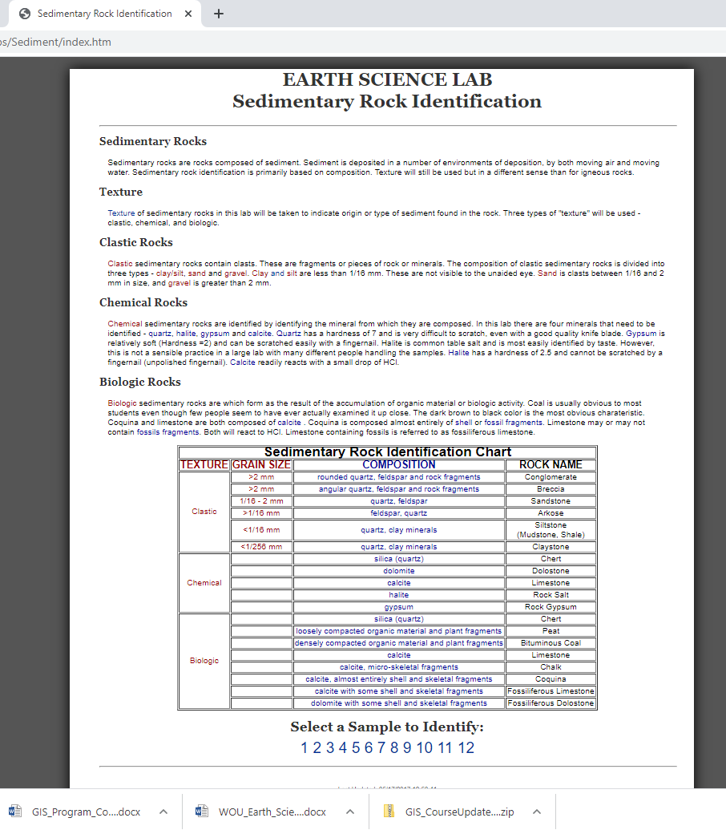

Read over the explanatory paragraphs summarizing the basics of sedimentary rock identification and classification that you learned about in Section A of the lab exercise above. Explore the linked web page showing a summary of the Sedimentary Rock Texture Chart at the following URL:

<http://profharwood.x10host.com/GEOL101/Labs/Sediment/texture.htm> and shown in the screen capture below.

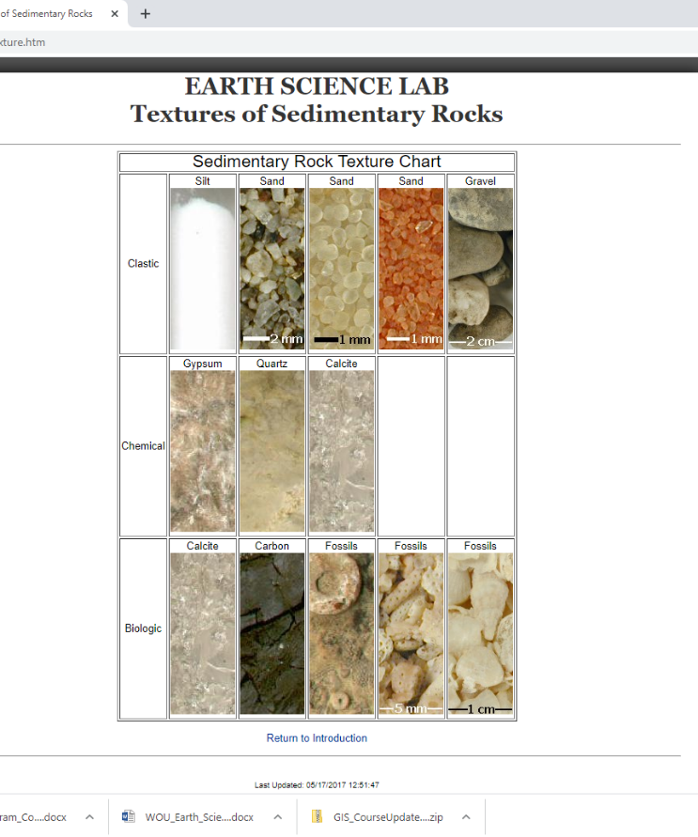

1. **Sample Identification:** There are 12 unknown sedimentary rock samples listed with links at the bottom of the lab introduction page:

<http://profharwood.x10host.com/GEOL101/Labs/Sediment/index.htm>

Note the instructions at the bottom of the page “select a sample to identify”. Systematically click through each sample from 1 to 12, and make observations regarding the sediment composition, hardness of the sediment particles, hydrochloric acid fizz test. Using the sample image, zoom in and out to make visual observations on sediment composition and grain size. Use the interactive radio buttons to test for acid effervescence (“fizz”) and hardness (on scale of 1-10), and finally compare your observations to the rock classification chart shown on the Sedimentary Rock Classification Chart Figure 6.9 on p. 164, from Section A you completed above.

Once you have made your observations, fill out the interactive rock classification chart using the radio buttons in each section of the web page: Texture, Grainsize, Composition, Rock Name. Once you have made your observations and decisions on how to classify the rock sample image, click on the “Grade Identification” control button, for feedback on how you did on your observations. If you have correctly made observations and identified the sedimentary rock sample, you will receive a pop-up note that you are “correct” and will win the grand prize. If you have incorrectly made observations or mis-named the unknown sample, you will receive a pop-up message stating that “You Missed the Texture, Grain Size, Composition, Rock Name”; retry as many times as needed to come up with the correct answers for the unknown samples. **Once you have completed to exercise to your liking, with correct answers through observation, trial and error, fill in the data tables below for each specimen, summarizing your online results on this worksheet.**

**Sample 1**

Acid Fizz Test = yes or no?

Hardness Observations:

Texture:

Grainsize:

Composition:

Rock Name:

**Sample 2**

Acid Fizz Test = yes or no?

Hardness Observations:

Texture:

Grainsize:

Composition:

Rock Name:

**Sample 3**

Acid Fizz Test = yes or no?

Hardness Observations:

Texture:

Grainsize:

Composition:

Rock Name:

**Sample 4**

Acid Fizz Test = yes or no?

Hardness Observations:

Texture:

Grainsize:

Composition:

Rock Name:

**Sample 5**

Acid Fizz Test = yes or no?

Hardness Observations:

Texture:

Grainsize:

Composition:

Rock Name:

**Sample 6**

Acid Fizz Test = yes or no?

Hardness Observations:

Texture:

Grainsize:

Composition:

Rock Name:

**Sample 7**

Acid Fizz Test = yes or no?

Hardness Observations:

Texture:

Grainsize:

Composition:

Rock Name:

**Sample 8**

Acid Fizz Test = yes or no?

Hardness Observations:

Texture:

Grainsize:

Composition:

Rock Name:

**Sample 9**

Acid Fizz Test = yes or no?

Hardness Observations:

Texture:

Grainsize:

Composition:

Rock Name:

**Sample 10**

Acid Fizz Test = yes or no?

Hardness Observations:

Texture:

Grainsize:

Composition:

Rock Name:

**Sample 11**

Acid Fizz Test = yes or no?

Hardness Observations:

Texture:

Grainsize:

Composition:

Rock Name:

**Sample 12**

Acid Fizz Test = yes or no?

Hardness Observations:

Texture:

Grainsize:

Composition:

Rock Name: